|  |
| --- |
| **<MOVIE THEATER SYSTEM>**  System Design Specification |

**Document History and Information**

**History of Amendments:**

|  |  |  |  |  |
| --- | --- | --- | --- | --- |
| **Date** | **Version** | **Modified section** | **Summary of change** | **Author** |
|  |  |  |  |  |
|  |  |  |  |  |
|  |  |  |  |  |

**Distributed for Review**

This document has been distributed for the following to review:

|  |  |  |  |
| --- | --- | --- | --- |
| **Name** | **Title and Company** | **Issue Date** | **Revision** |
|  |  |  |  |
|  |  |  |  |
|  |  |  |  |
|  |  |  |  |

**Approvals**

This document requires the following approvals:

|  |  |  |  |
| --- | --- | --- | --- |
| **Name** | **Signature** | **Title** | **Issue Date** |
|  |  |  |  |
|  |  |  |  |
|  |  |  |  |
|  |  |  |  |

**Associated Documents**

This document is associated with the following other documents:

|  |  |  |  |  |
| --- | --- | --- | --- | --- |
| **Name** | **Title and Originator’s**  **Reference** | **Source** | **Issue Date** | **Version** |
|  |  |  |  |  |
|  |  |  |  |  |
|  |  |  |  |  |
|  |  |  |  |  |

Contents

1. INTRODUCTION. 2

2. Employee Management 2

2.1. Class diagram 2

2.2. Sequence Diagram 2

2.2.1. View employee list/Search employee 2

2.2.2. Create new employee account 3

2.2.3. Update employee’s status 4

2.2.4. Update employee 4

2.2.5. Delete employee 5

2.3. Screen 5

2.3.1. List screen 5

2.3.2. User Details screen 6

2.3.3. Add screen 8

2.3.4. Edit screen 10

2.3.5. Delete screen 11

2.3.6. Update status screen 12

# INTRODUCTION.

## Employee Management

## Class diagram

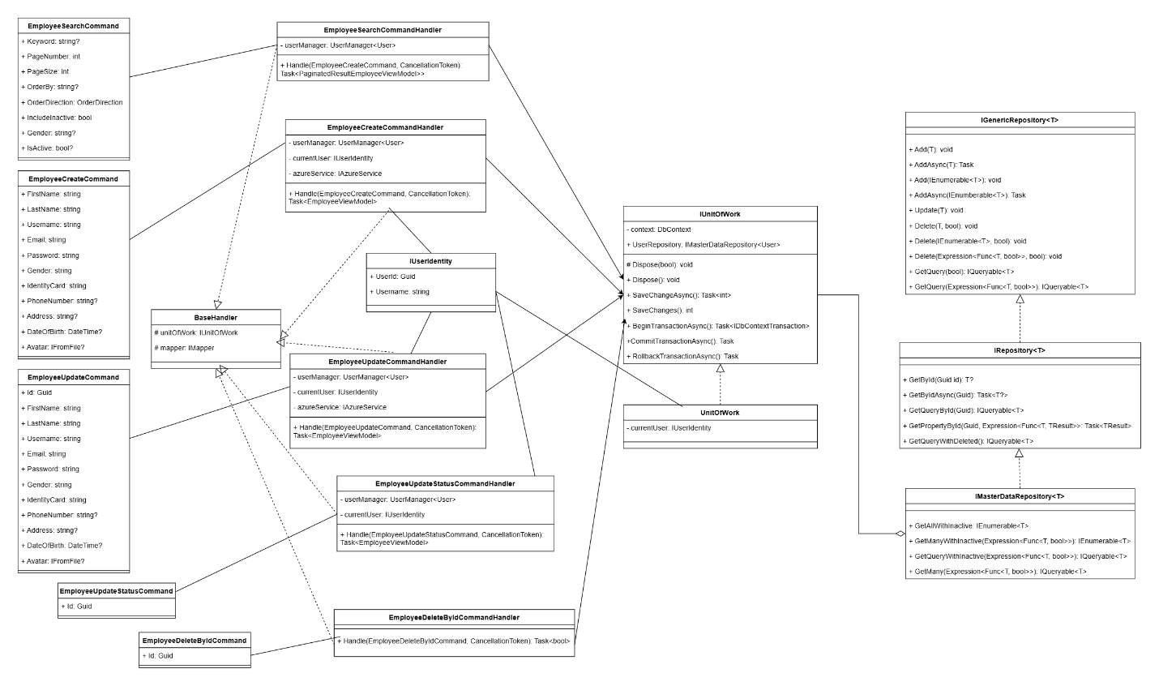

## Sequence Diagram

### View employee list/Search employee

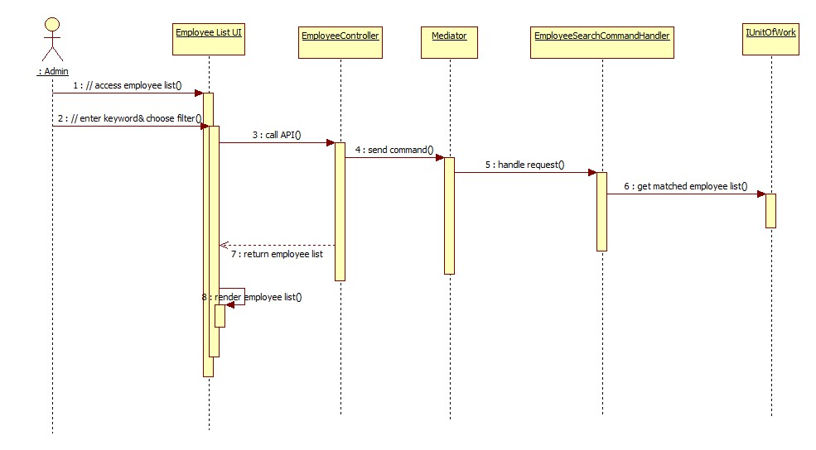

### Create new employee account

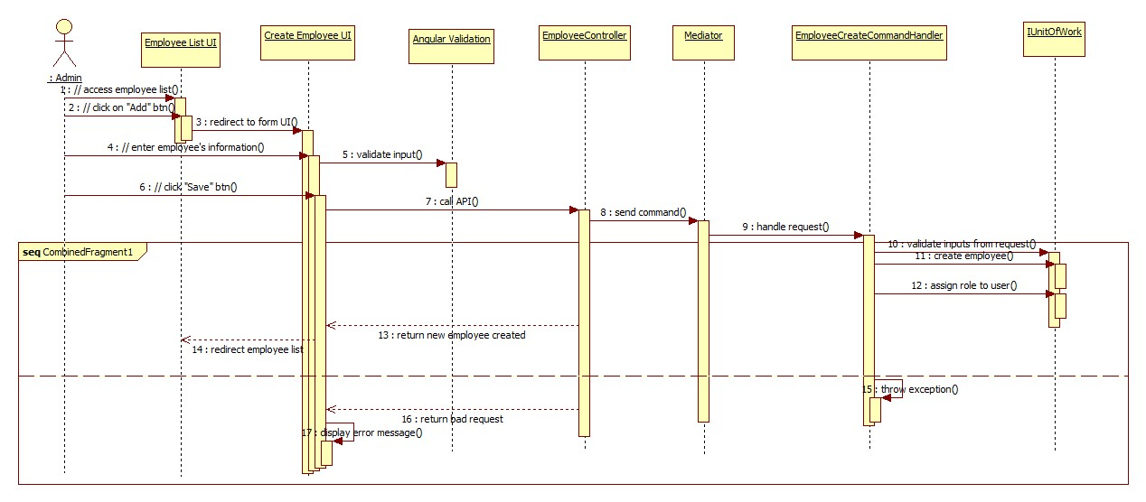

### Update employee’s status

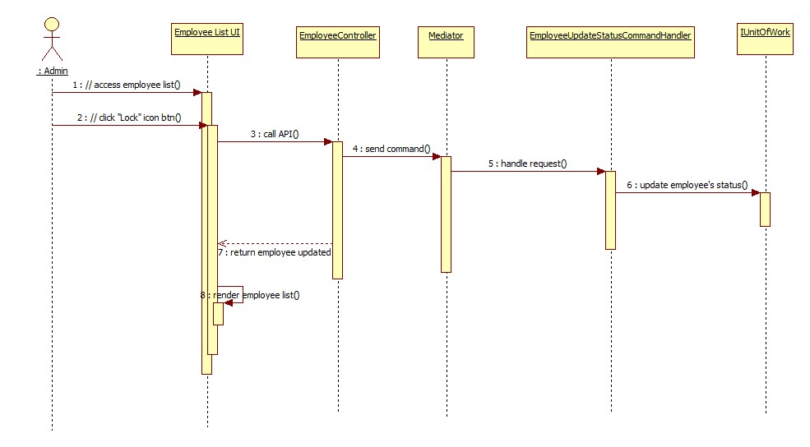

### Update employee

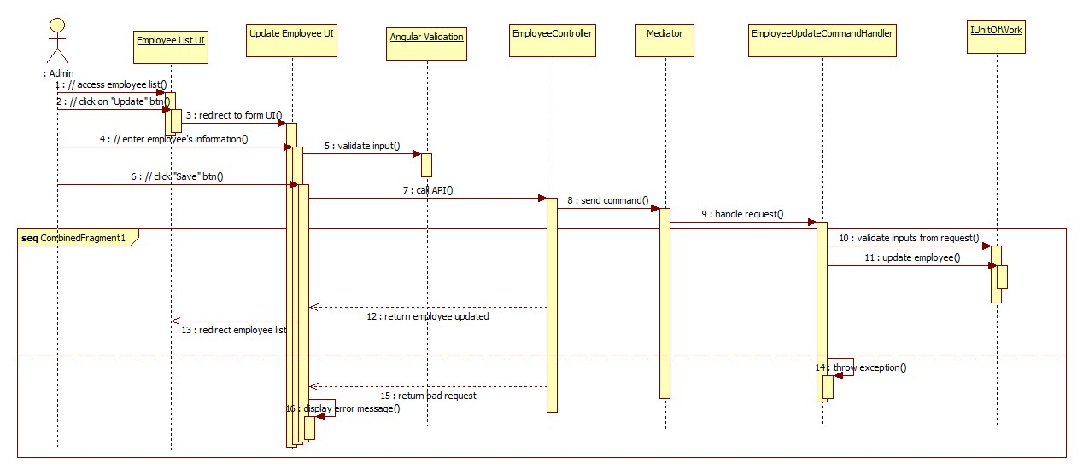

### Delete employee

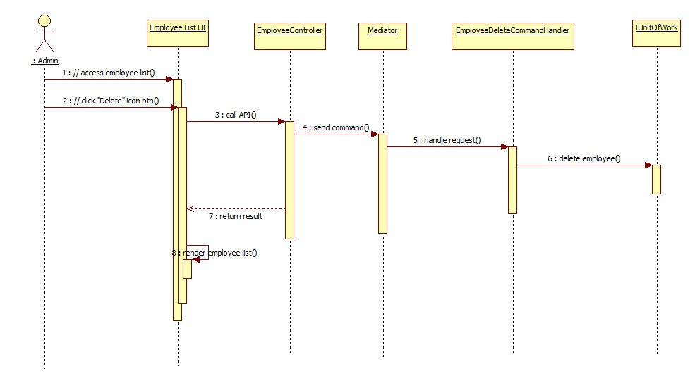

## Screen

### List screen

#### Main flow

|  |  |
| --- | --- |
| **Screen** | View employee list |
| **Description** | This use case allows admin to view list of users |
| **Screen Access** | Admin login in the system successfully-> Admin clicks “User Management” -> “Employee List” on the horizontal left menu bar -> System shows user list |

#### User interface

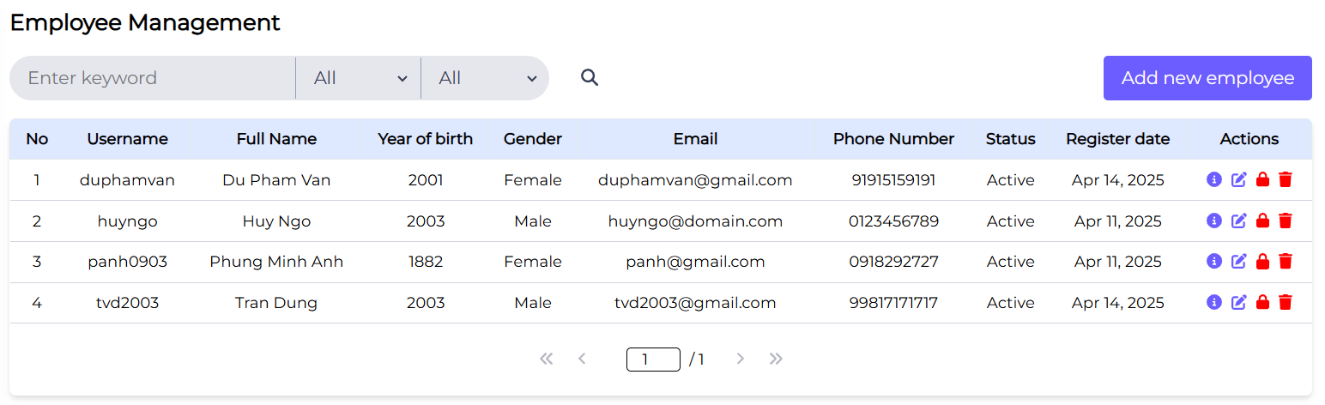

#### Validation Rule/Data mapping

|  |  |  |
| --- | --- | --- |
| **Field** | **Type** | **Description** |
| Name of module | Label | * Show the name of module “Employee Management” |
| Name of submodule | Label | * Show the name of sub-function “Employee List” |
| Search box | Textbox | * User input keyword in the search box to search |
| Gender | Combo-box | * User select gender to search. * List of roles: Male, Female and All |
| Is Active | Combo-box | * User select status to search. * List of roles: Active, Inactive and All |
| Add New Employee | Icon | * User clicks on “Add New Employee” button, system shows “Create Employee” UI |
| User name | Label | * Display username * Mapping to field in DB: Users.UserName |
| Full Name | Label | * Display full name * Mapping to field in DB: Users.DisplayName |
| Email | Label | * Display email * Mapping to field in DB: Users.Email |
| Phone number | Label | * Display phone number * Mapping to field in DB: Users.PhoneNumber |
| Gender | Label | * Display gender * Mapping to field in DB: Users.Gender |
| Year of birth | Label | * Display year of birth * Mapping to field in DB: Users.DateOfBirth, with custom pipe |
| Status | Label | * Display status * Mapping to field in DB: Users.IsActive, with custom pipe |
| Register Date | Label | * Display register date * Mapping to field in DB: Users.CreatedAt, with custom pipe |

### User Details screen

#### Main flow

|  |  |
| --- | --- |
| **Screen** | User Details |
| **Description** | Allow Administrator to view existing employee. |
| **Screen Access** | Admin click icon “View” in the Employee list -> System show Employee Details screen |

#### User interface

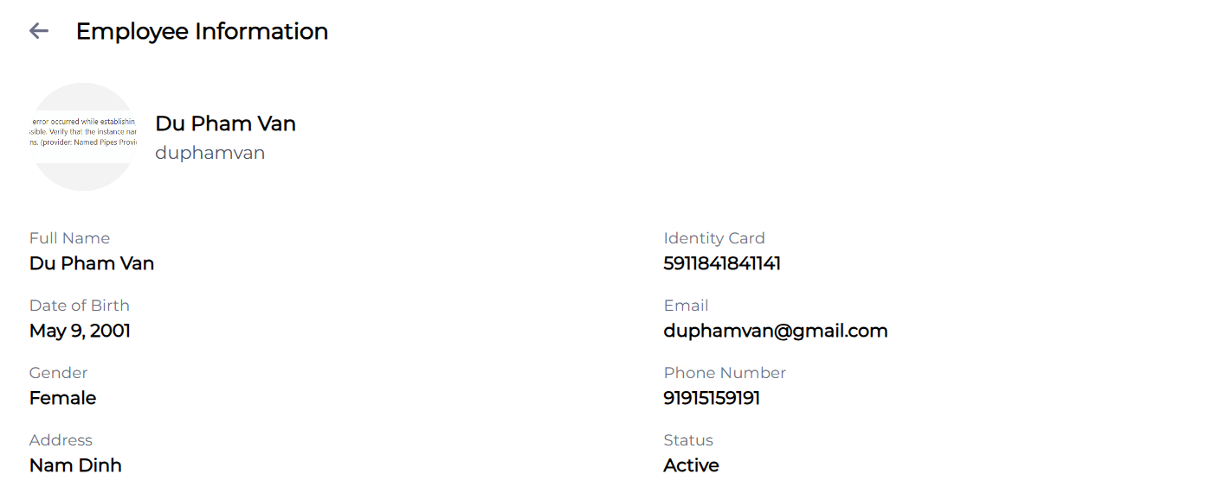

#### Validation Rule/Data mapping

|  |  |  |
| --- | --- | --- |
| **Field** | **Type** | **Description** |
| Name of function | Label | * Show the name of the function “User Details” |
| Full Name | Textbox | * Name of User * Mapping to field in DB: Users.DisplayName |
| Email | Textbox | * Email of User * Mapping to field in DB: Users.Email |
| D.O.B | Icon with Text | * Date of birth of User * Mapping to field in DB: Users.DateOfBirth |
| Address | Textbox | * Address of User * Mapping to field in DB: Users.Address |
| Phone number | Textbox | * Phone number of User * Mapping to field in DB: Users.PhoneNumber |
| Gender | Textbox | * Gender of User * Mapping to field in DB: Users.Gender |
| Identity Card | Textbox | * Identity Card of User * Mapping to field in DB: Users.IdentityCard |
| Username | Textbox | * Username of User * Mapping to field in DB: User.Username |
| Status | Textbox | * Status of User * Mapping to field in DB: User.IsActive |
| Icon btn | Button | * Back to list screen |

### Add screen

#### Main flow

|  |  |
| --- | --- |
| **Screen** | Create Employee |
| **Description** | Allow Administrator to add new employee. |
| **Screen Access** | Admin click icon “Add New employee” in the User list -> System show Create employee screen -> User enter information and click submit -> System creates new employee account. |

#### User interface

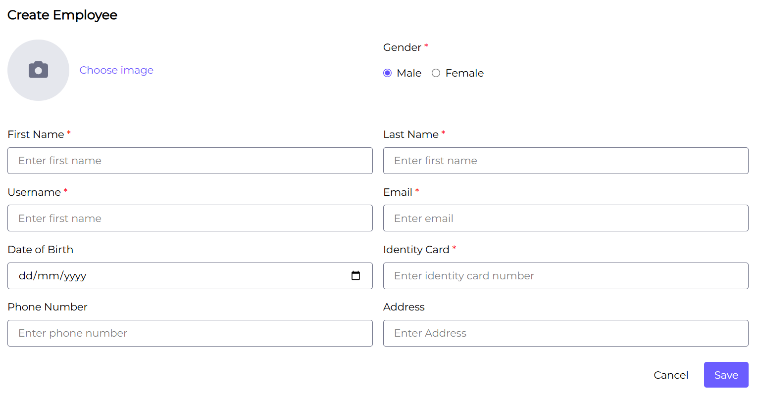

#### Validation Rule/Data mapping

|  |  |  |
| --- | --- | --- |
| **Field** | **Type** | **Description** |
| Name of function | Label | * Show the name of the function “Create User” |
| First Name | Textbox | * Name of User * Is mandatory * Insert into field in DB: Users.FirstName |
| Last Name | Textbox | * Name of User * Is mandatory * Insert into field in DB: Users.LastName |
| Email | Textbox | * Email of User * Is mandatory * Insert into field in DB: Users.Email |
| D.O.B | Icon with Text | * Date of birth of User * Default to blank * Insert into field in DB: Users.DateOfBirth |
| Address | Textbox | * Address of User * Default to blank * Insert into field in DB: Users.Address |
| Phone number | Textbox | * Phone number of User * Default to blank * Insert into field in DB: Users.PhoneNumber |
| Gender | Combo-box | * Gender of User * Is mandatory * Insert into field in DB: Users.Gender |
| Identity card | Combo-box | * Identity card of User * Is mandatory * Insert into field in DB: User.IdentityCard |
| Save | Button | * Submit button * Submit user and back to list screen |
| Cancel | Button | * Cancel button * Cancel to add new and back to list screen |

### Edit screen

#### Main flow

|  |  |
| --- | --- |
| **Screen** | Edit User |
| **Description** | Allow Administrator to edit existing users. |
| **Screen Access** | Admin click icon “Edit” in the Employee list -> System show Edit Employee screen -> User enter information and click submit -> System edits that existing Employee account. |

#### User interface

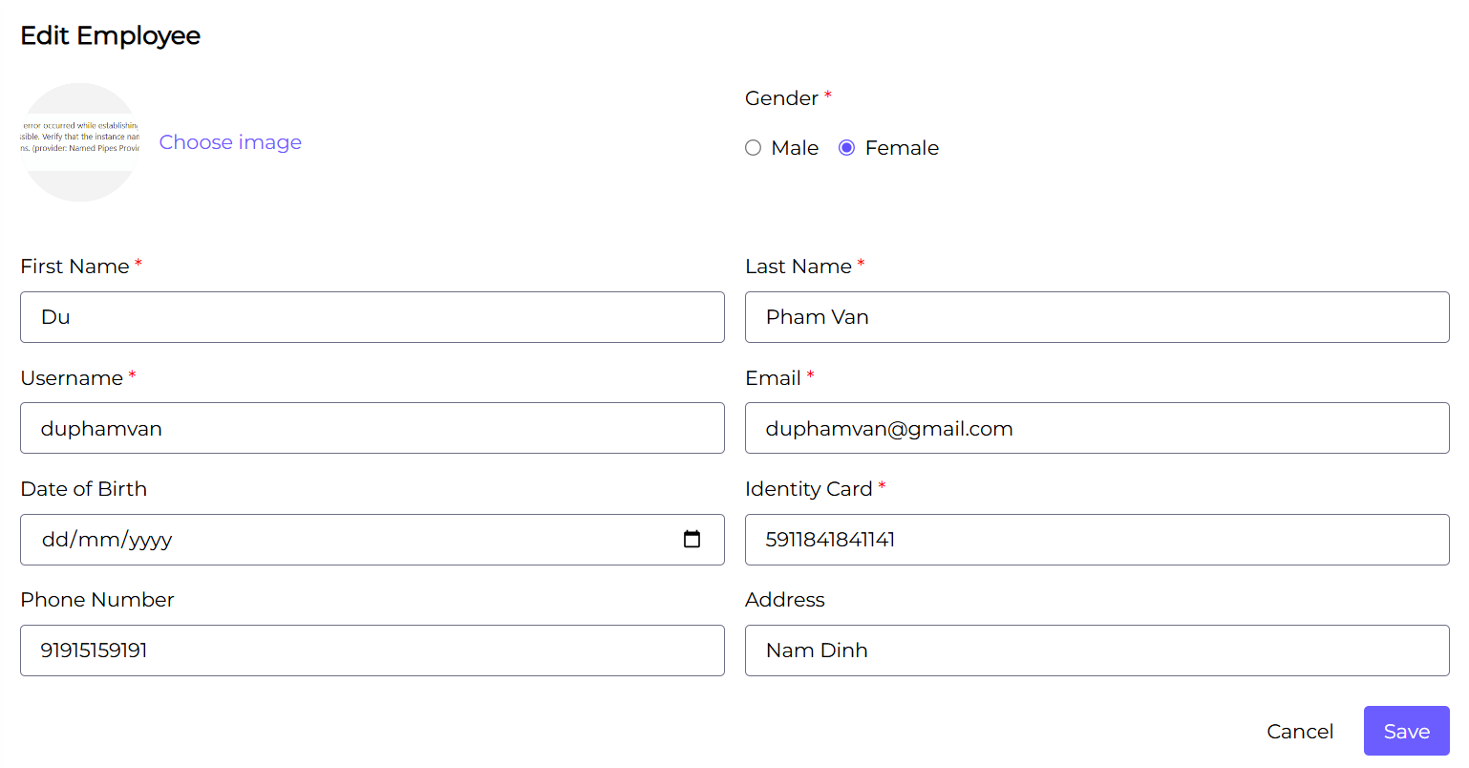

#### Validation Rule/Data mapping

|  |  |  |
| --- | --- | --- |
| **Field** | **Type** | **Description** |
| Name of function | Label | * Show the name of the function “Update Employee” |
| First Name | Textbox | * Name of User * Is mandatory * Insert into field in DB: Users.FirstName |
| Last Name | Textbox | * Name of User * Is mandatory * Insert into field in DB: Users.LastName |
| Email | Textbox | * Email of User * Is mandatory * Insert into field in DB: Users.Email |
| D.O.B | Icon with Text | * Date of birth of User * Default to blank * Insert into field in DB: Users.DateOfBirth |
| Address | Textbox | * Address of User * Default to blank * Insert into field in DB: Users.Address |
| Phone number | Textbox | * Phone number of User * Default to blank * Insert into field in DB: Users.PhoneNumber |
| Gender | Combo-box | * Gender of User * Is mandatory * Insert into field in DB: Users.Gender |
| Identity card | Combo-box | * Identity card of User * Is mandatory * Insert into field in DB: User.IdentityCard |
| Save | Button | * Submit button * Submit user and back to list screen |
| Cancel | Button | * Cancel button * Cancel to add new and back to list screen |

### Delete screen

#### Main flow

|  |  |
| --- | --- |
| **Screen** | Delete Employee |
| **Description** | Allow Administrator to delete existing employee. |
| **Screen Access** | Admin click icon “Delete” in the Employee list -> System show Delete Employee modal -> Admin click on “Delete” button -> System delete that Employee account. |

#### User interface

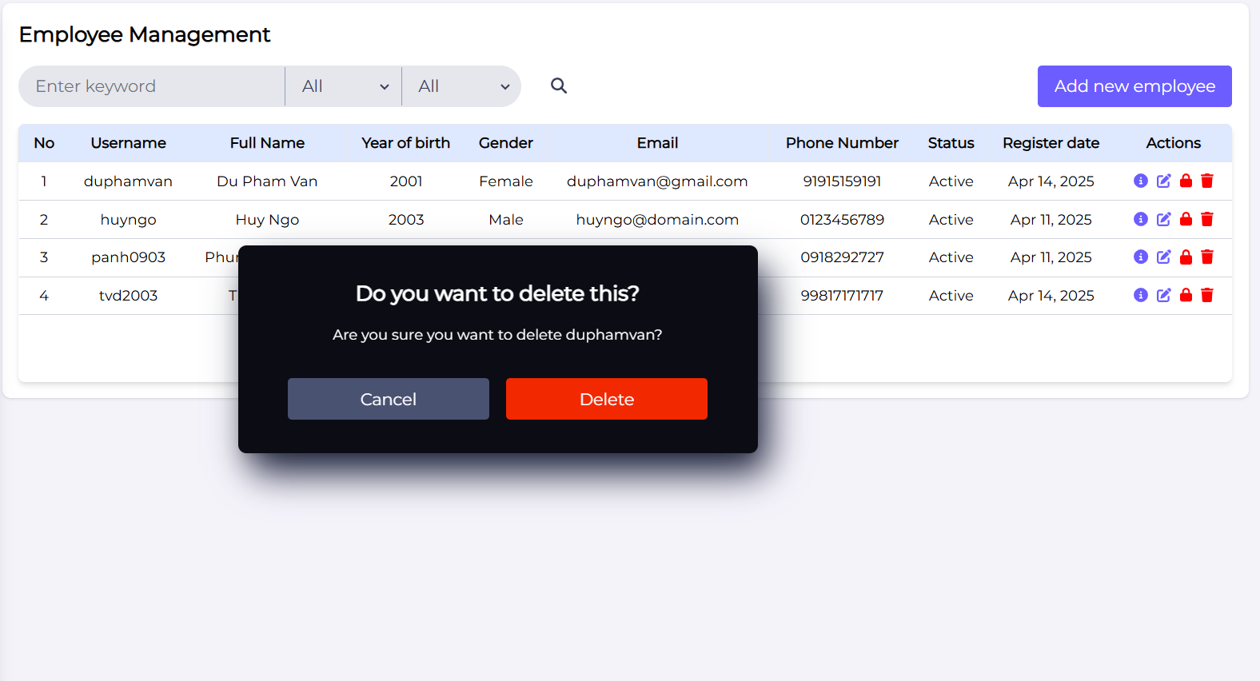

#### Validation Rule/Data mapping

|  |  |  |
| --- | --- | --- |
| **Field** | **Type** | **Description** |
| Name of function | Label | * Show the name of the function “Delete Employee” |
| Delete | Button | * Confirm button * Delete user and hide modal |
| Cancel | Button | * Cancel button * Cancel to delete account and hide modal |

### Update status screen

#### Main flow

|  |  |
| --- | --- |
| **Screen** | Update status for Employee |
| **Description** | Allow Administrator to update status for existing employee. |
| **Screen Access** | Admin click icon “Lock” in the Employee list -> System show Update status Employee modal -> Admin click on “Update” button -> System update status of that Employee account. |

#### User interface

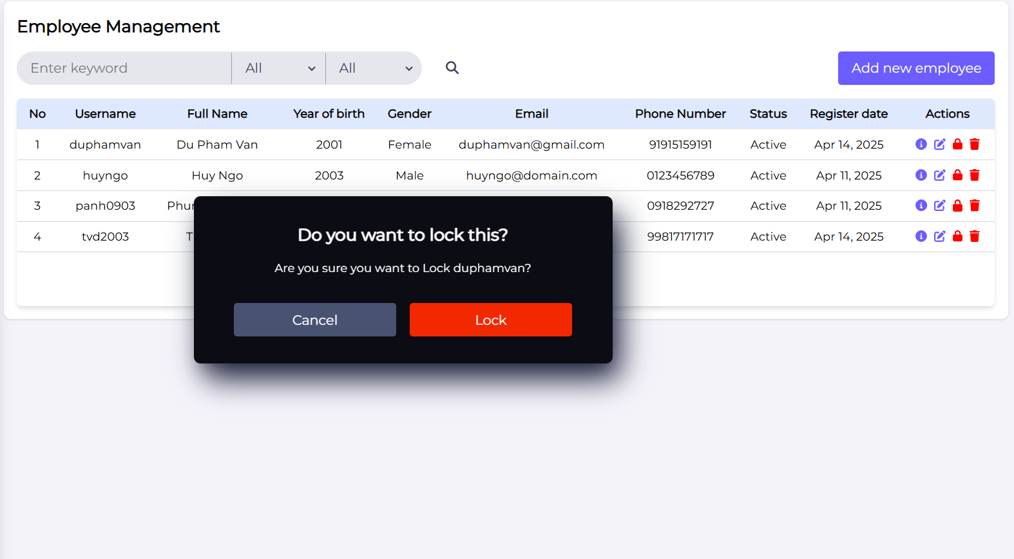

#### Validation Rule/Data mapping

|  |  |  |
| --- | --- | --- |
| **Field** | **Type** | **Description** |
| Name of function | Label | * Show the name of the function “Update status for Employee” |
| Delete | Button | * Confirm button * Update status and hide modal |
| Cancel | Button | * Cancel button * Cancel to update status and hide modal |